Document -- User-Access-to-Cluster.docx

Service accounts : used by pods to access Kubernetes api.

Useraccounts means having access key and password kind of thing.

Service accounts are similar to IAM Roles.

Kubernetes has provided a dashboard.

Document -- K8S-Dashboard.docx

kubectl apply -f https://raw.githubusercontent.com/kubernetes/dashboard/v2.6.0/aio/deploy/recommended.yaml

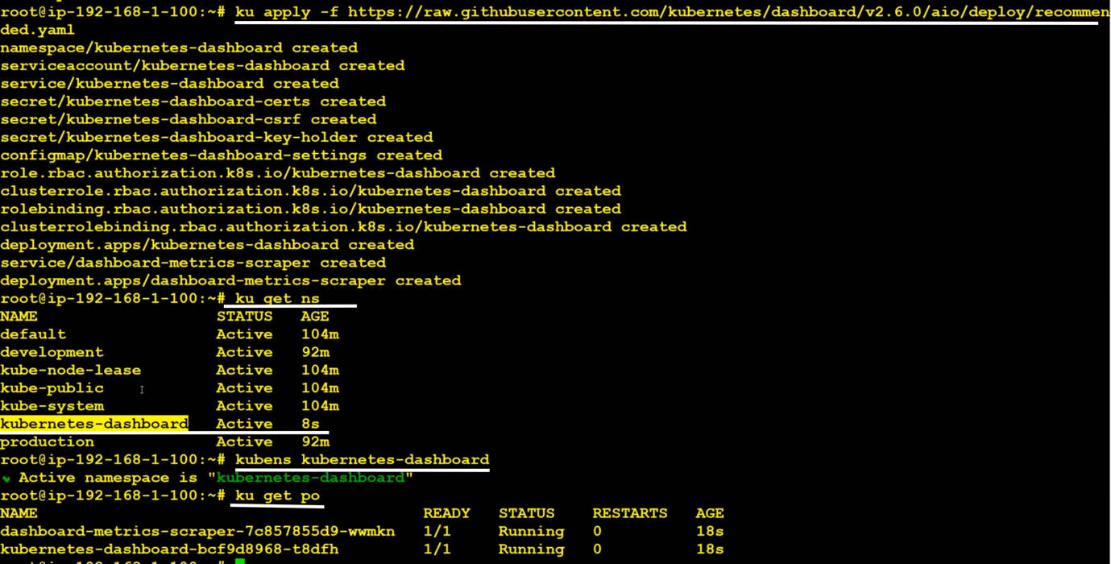

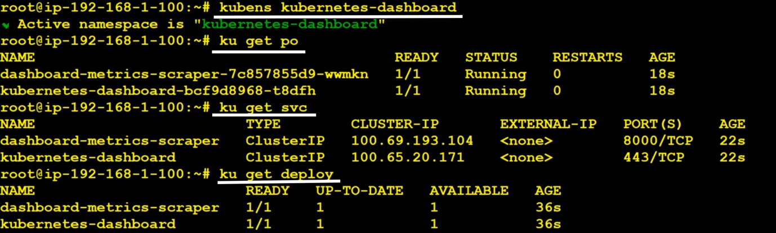

When we create kubernetes dashboard, automatically it creates a deployment(it internally has pods). We have to expose that deployment using service(nodePort). To expose the deployment, we have to know the target-port on which application is running. To know that we can use describe

>> kubectl describe svc kubernetes- dashboard

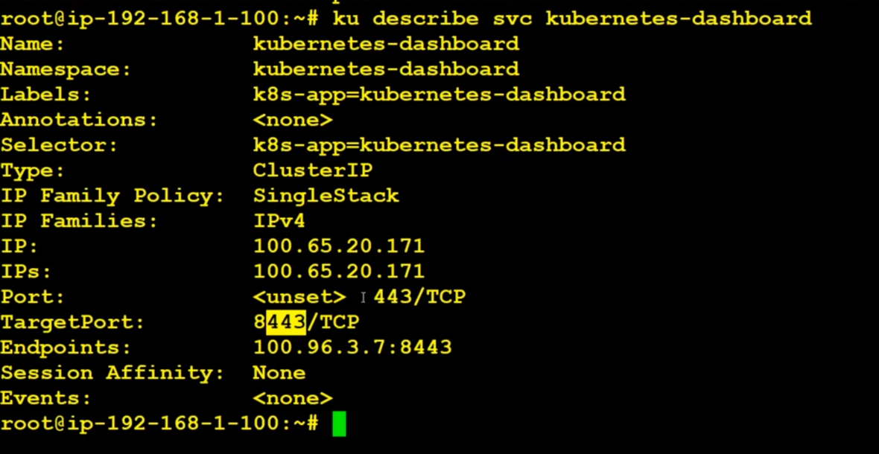

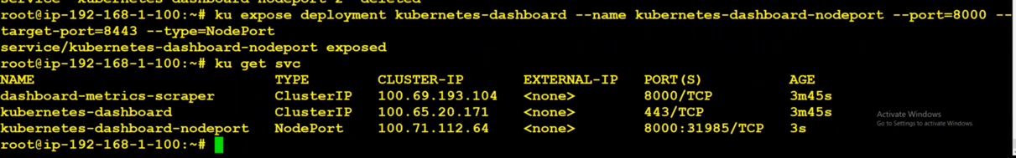

If we try to access this dashboard, we will get like this

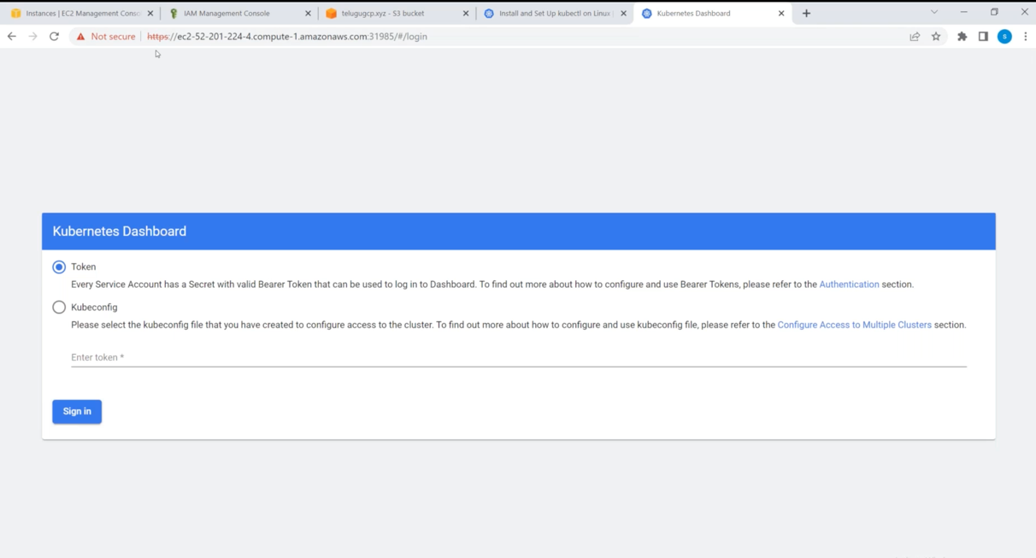

TO get the token execute the following:

kubectl -n kubernetes-dashboard describe secret $(kubectl -n kubernetes-dashboard get secret | grep admin-user | awk '{print $1}')

While deploying Kubernetes dashboard, it creates a service account. 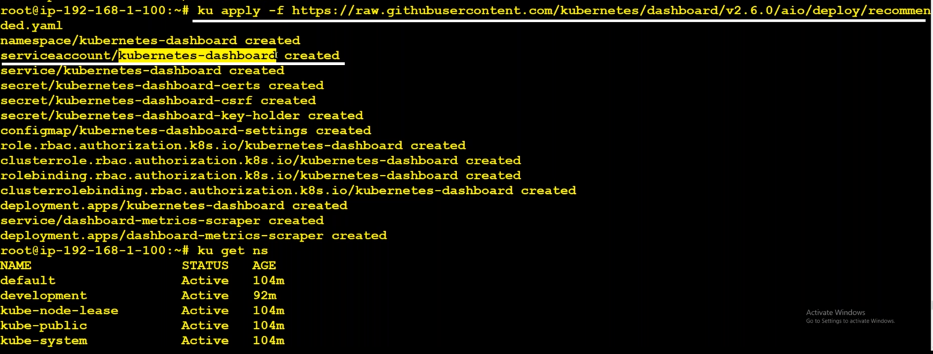

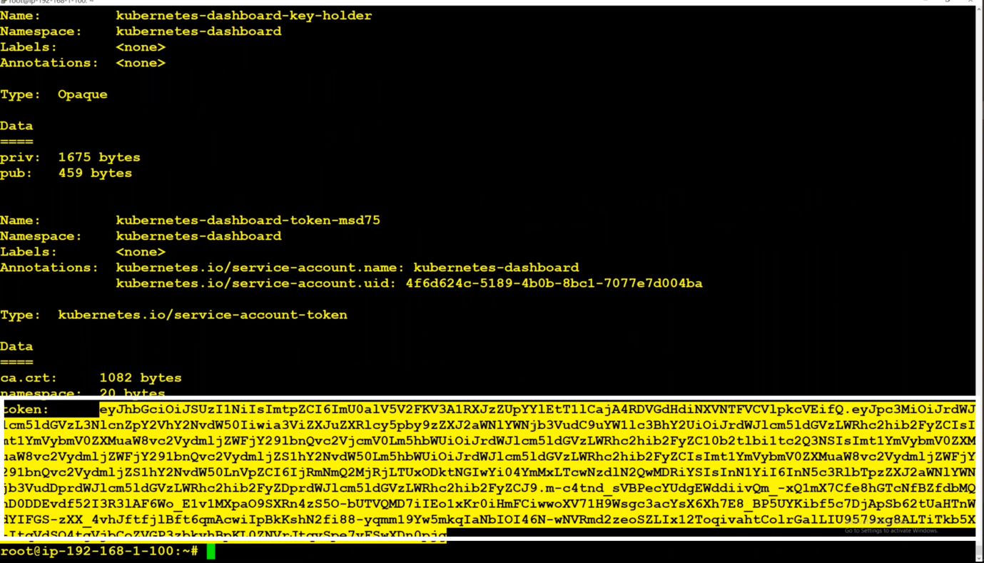

Copy the token and paste it on the token field of Kubernetes dashboard.

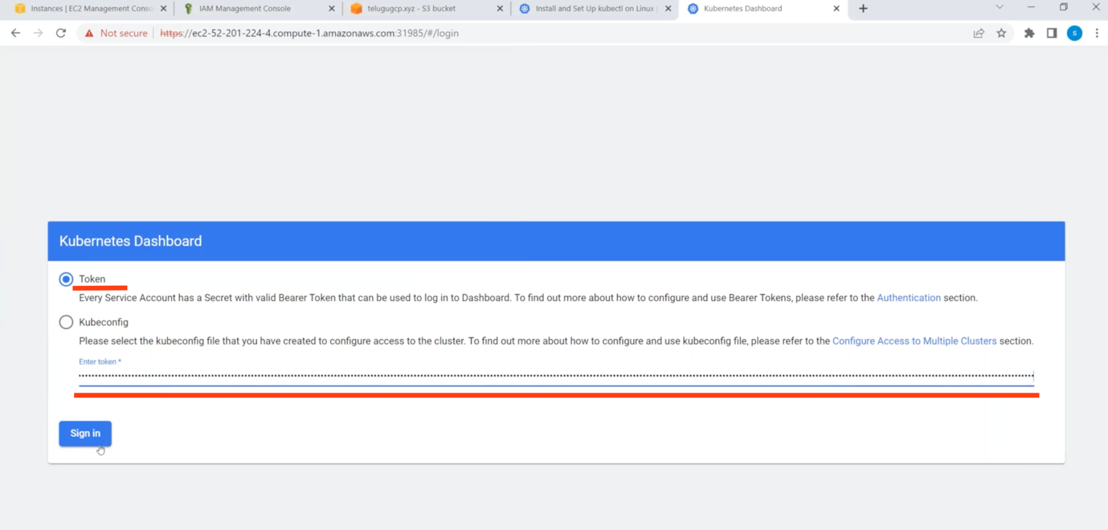

apiVersion: rbac.authorization.k8s.io/v1

kind: ClusterRoleBinding

metadata:

name: admin-user

roleRef:

apiGroup: rbac.authorization.k8s.io

kind: ClusterRole

name: cluster-admin

subjects:

- kind: ServiceAccount

name: admin-user

namespace: kubernetes-dashboard

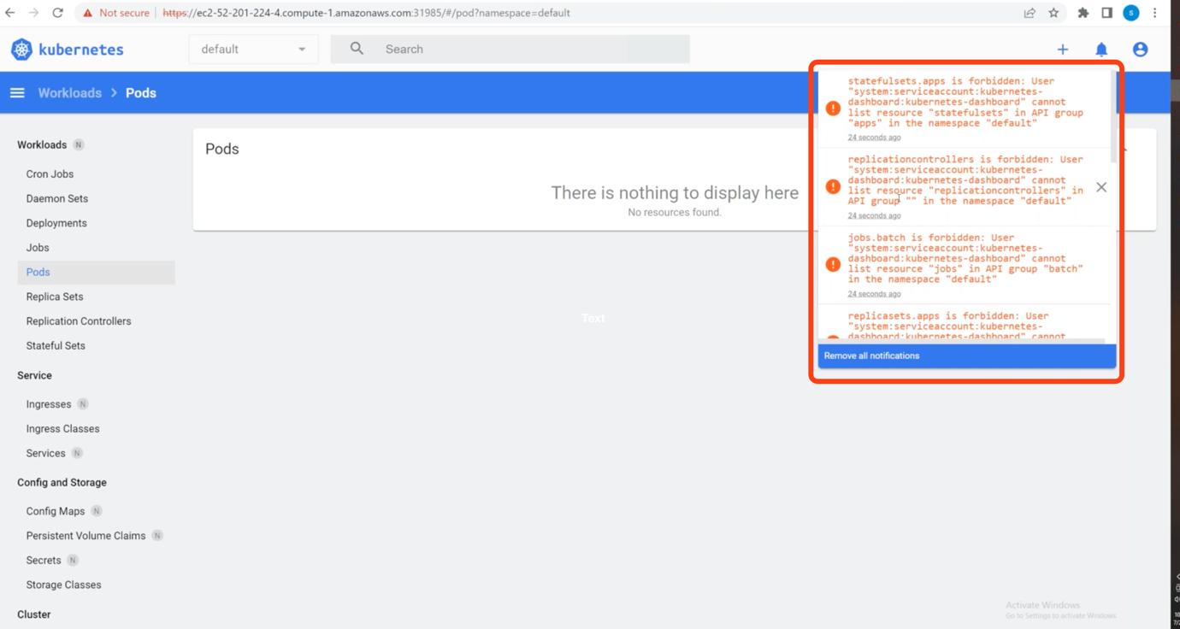

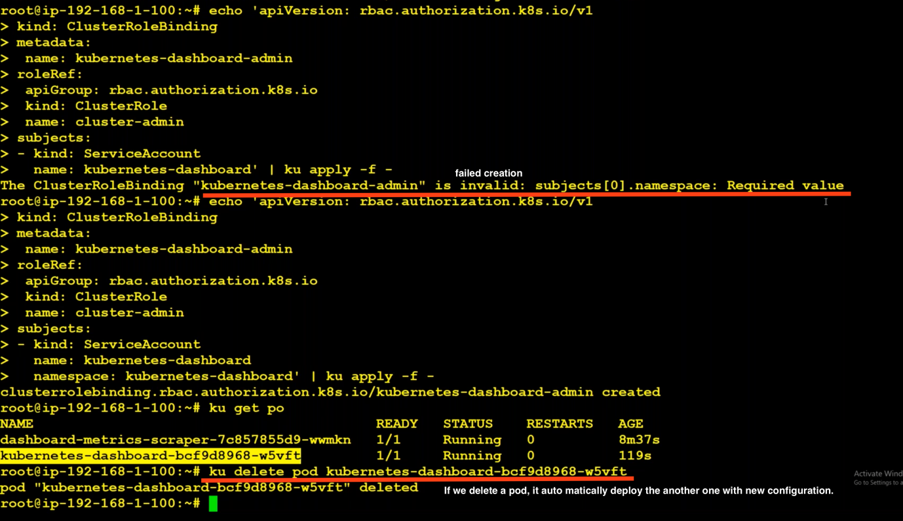

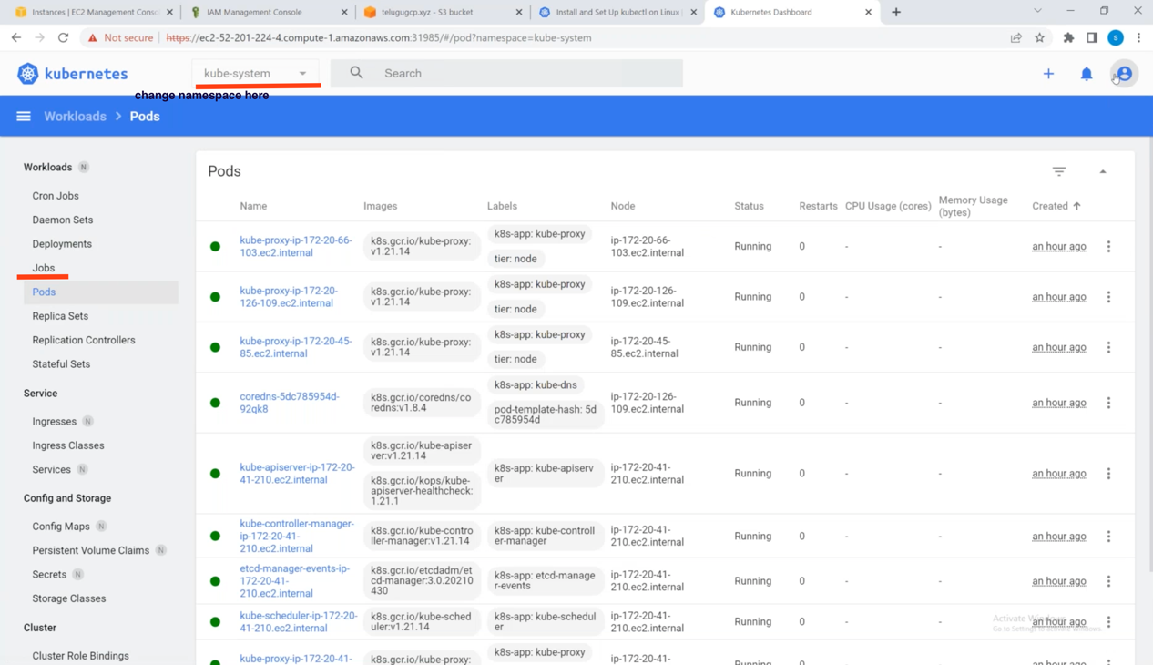

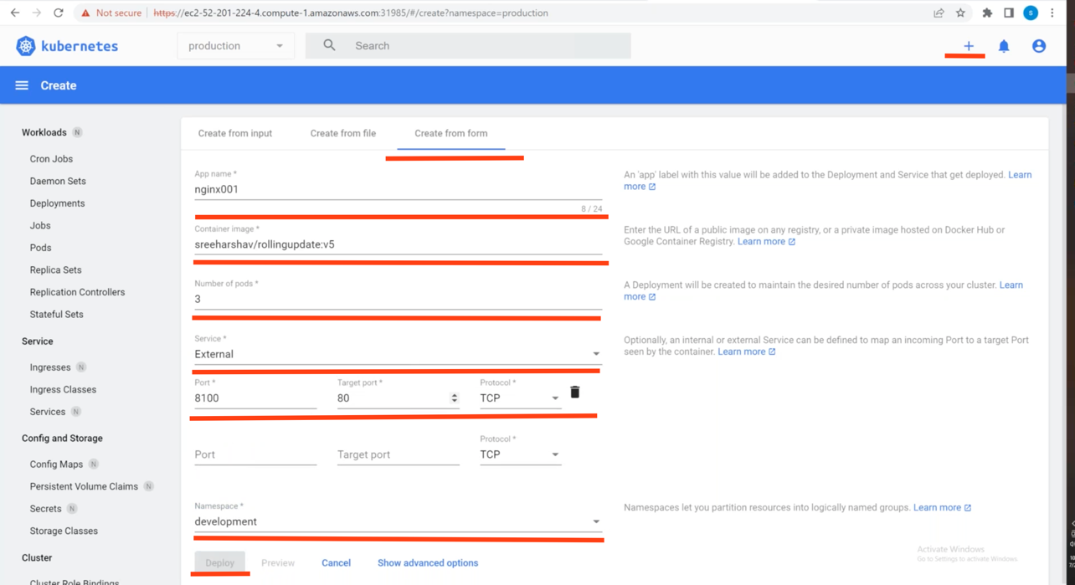

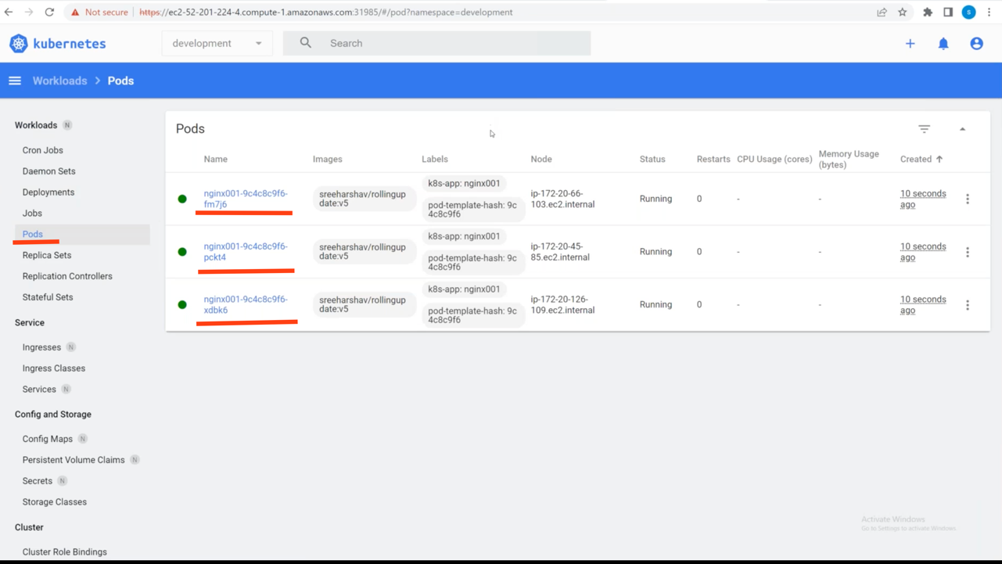

This Kubernetes-dashboard is pod, but how is it showing all the details of namespaces ?

It is because of the service account that is created while deploying Kubernetes-dashboard.

Pods uses service-accounts. Admins uses user-accounts.

Portainer :

Document : Portainer-with-serviceaccount.docx

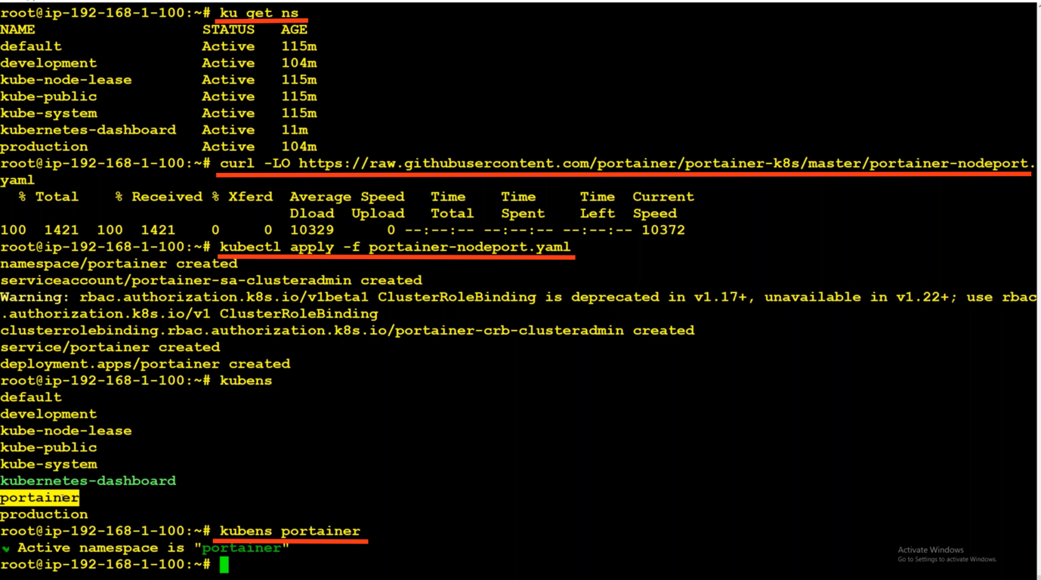

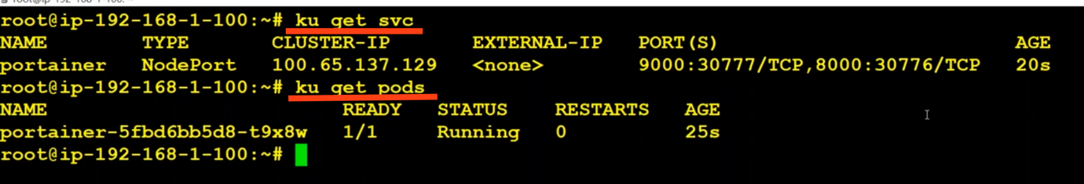

If not working try using https rather than http.

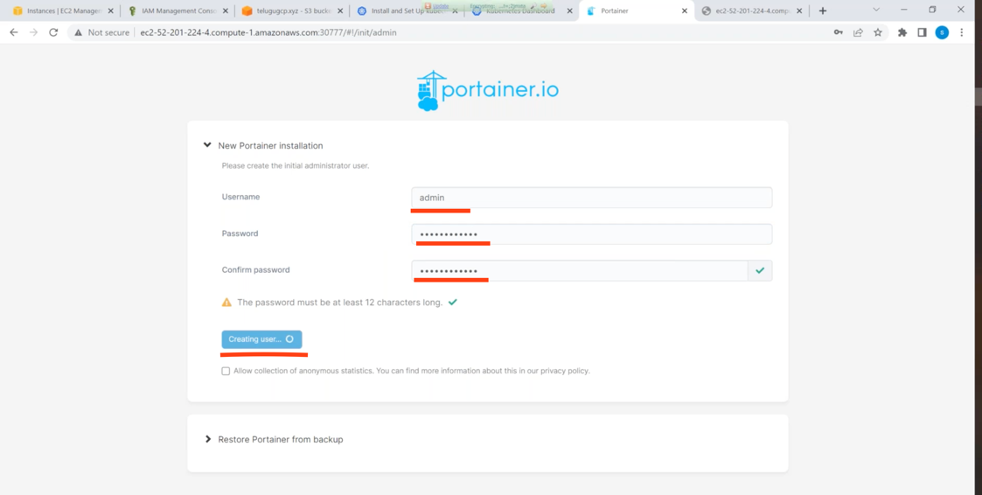

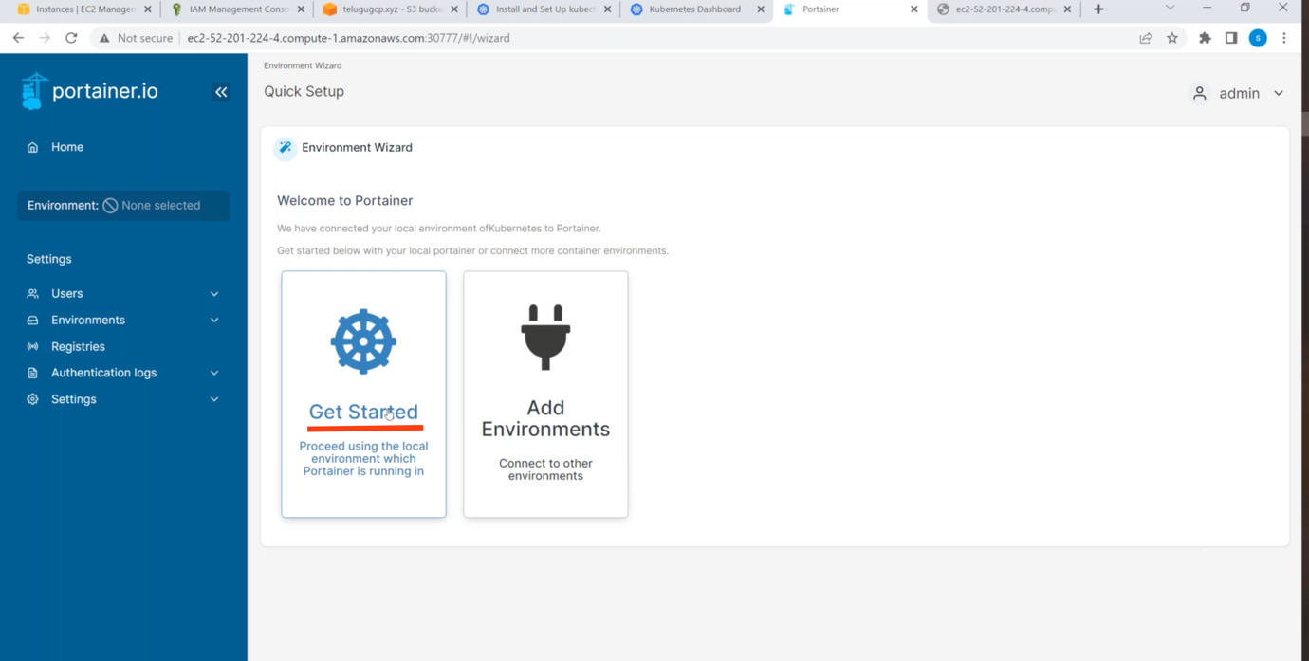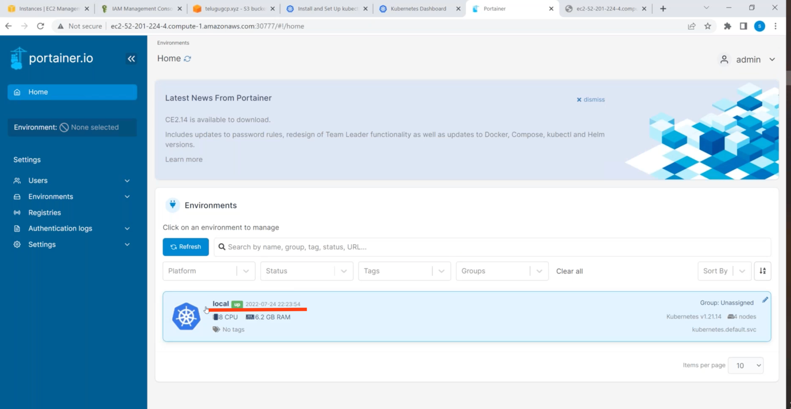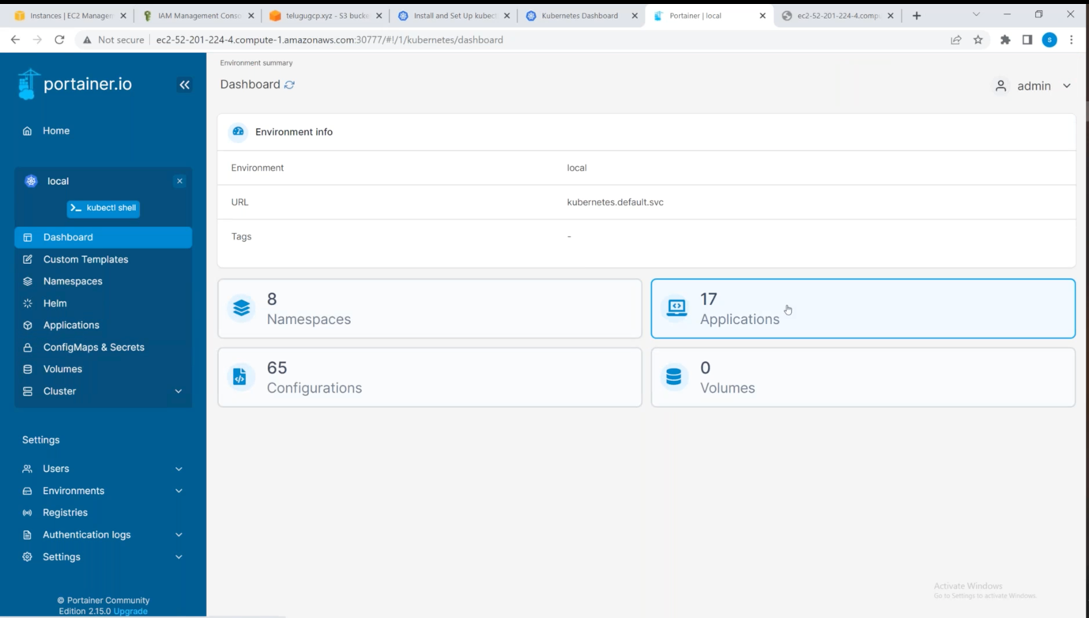

In portainer, interface is good, it has logs for particular pods. It getting all those information by talking to api-server. It requires authentication to go there. So, it is creating service account.

By using lens, we can connect from outside.

But in Kubernetes-dsahboard and portainer the application is running inside the cluster. It uses service-accounts, it doesn’t require kubeconfig file.

